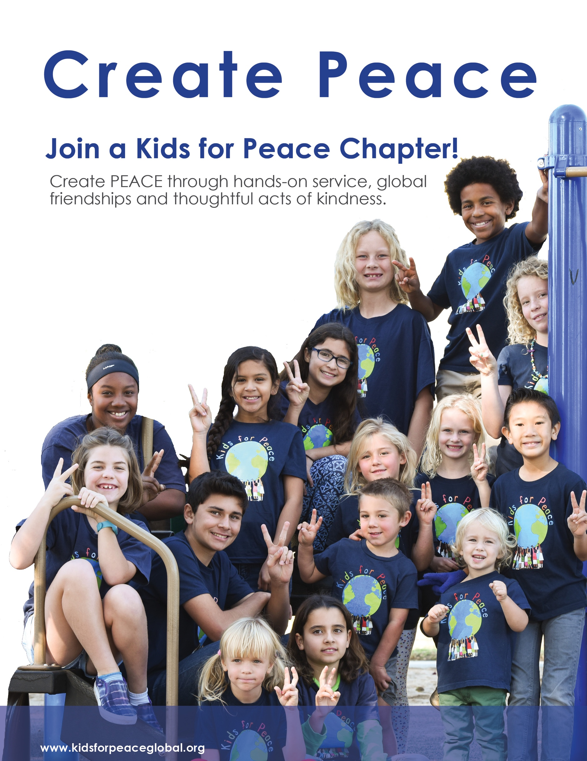

Boys and Girls of all ages are welcome! Monthly meetings, peacebuilding, community service projects & lots of fun.

Join us! Starting in September!

Contact: